**Python Coding Assessment(20-12-2023)**

**1.Explain Python Module with examples  
a. Import module in Python   
.Renaming the Python module**

Python module is a file that contains a code to perform a single task or multiple tasks. A module may contain anything like variables, functions or classes.

**Advantages of Module:**

**Code Reusability:** Here whatever the code that we are writing the python module it concisely reused by importing particular module in our program.

**Code Readability:** Basically python modules are enhance the code readability nothing but the user can easily understand the code in less time.

**Reduces Code Complexity:** By using modules ,the complexity of code is reduced we can make it as much as concise to use and maintain.

In python there are built in modules are user defines modules are there

**Built in Modules** like

math module used to perform mathematical operations. It contains predefined functions like

* abs used to finding the absolute values.
* Min used to perform the minimum value in given data
* Max used to perform the maximum value in given data.
* ,os module contains the operating system functions.
* datetime module contain the date and time functions etc

**User Defined Module:** These modules are created the user, For these type of functions user has to provide the code and used in programs.

Example: For instance we can make calculator as module to perform mathematical calculations.

**Import module**

If we are creating python module then it must be import in our program in order to use with the help of import statement.

**Syntax:**

Import module_name

Ex: import calculator

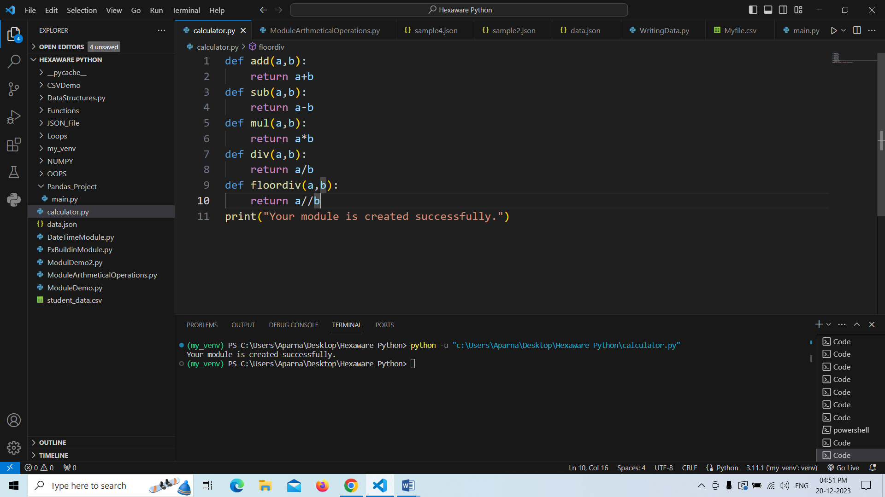

**Performing the Arithmetic Operations by using the calculator module.**

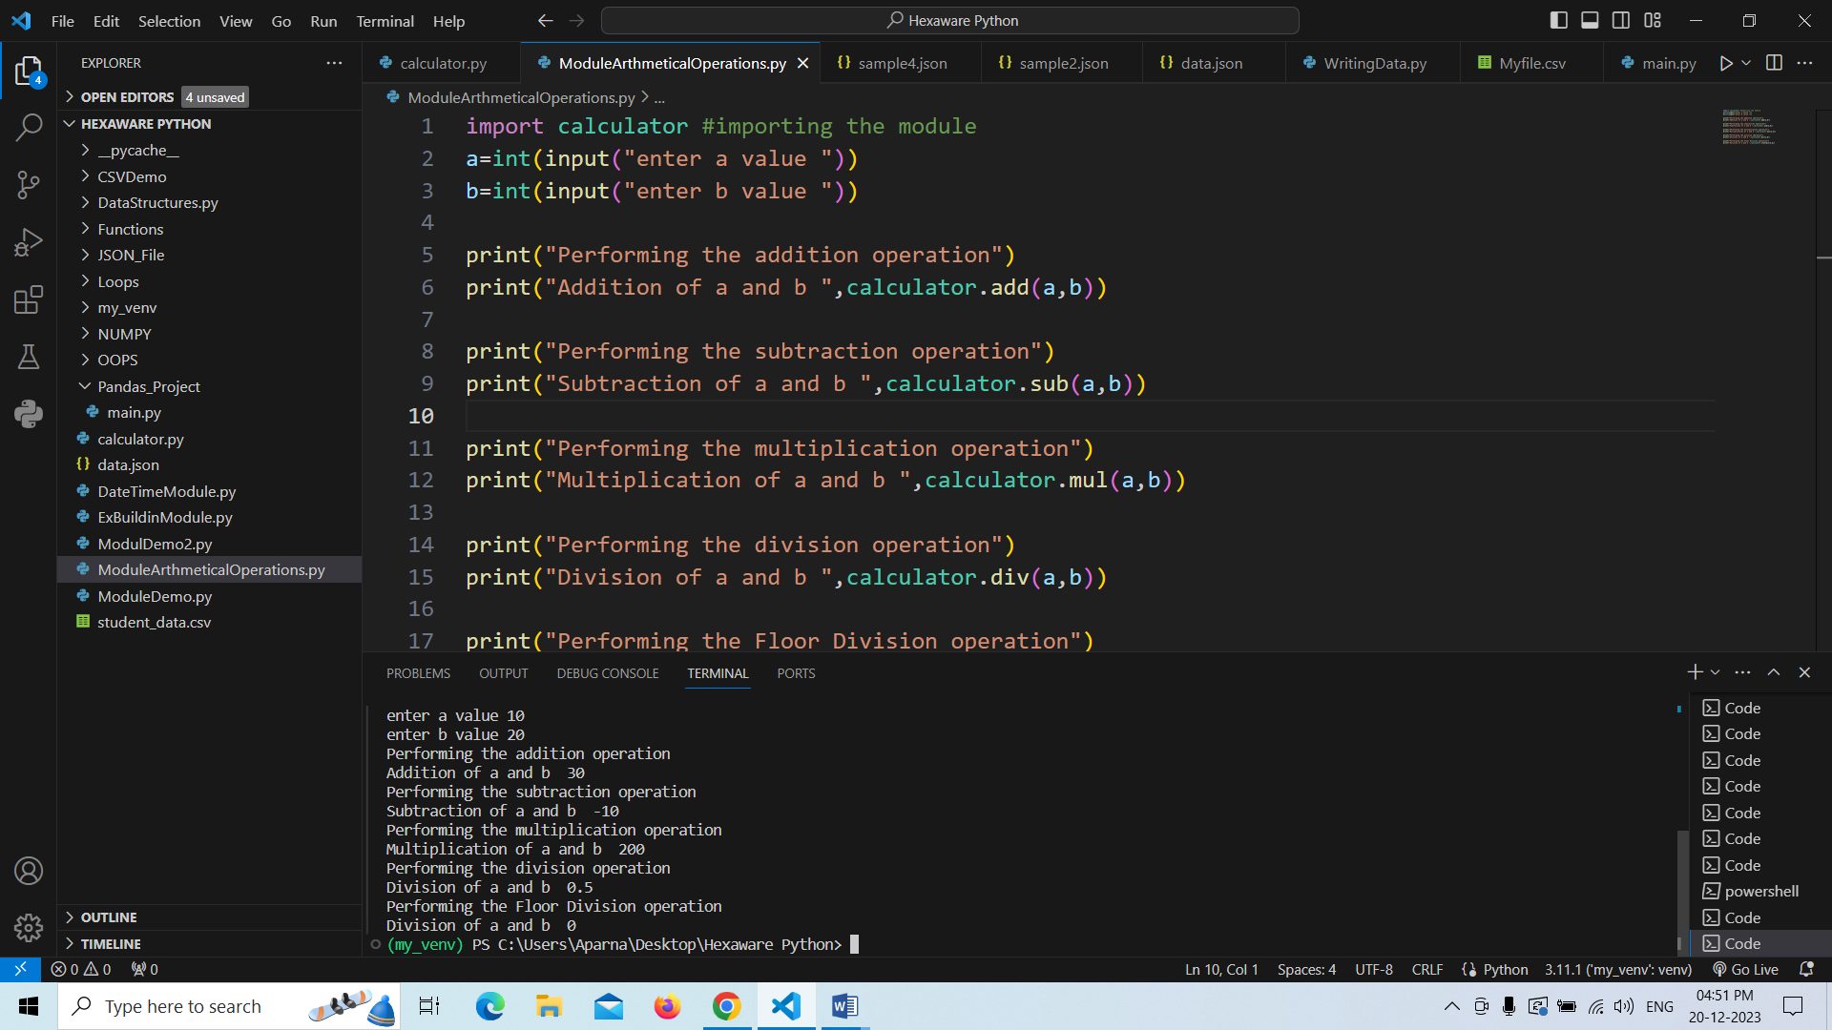

**Complete code:**

import calculator #importing the module

a=int(input("enter a value "))

b=int(input("enter b value "))

print("Performing the addition operation")

print("Addition of a and b ",calculator.add(a,b))

print("Performing the subtraction operation")

print("Subtraction of a and b ",calculator.sub(a,b))

print("Performing the multiplication operation")

print("Multiplication of a and b ",calculator.mul(a,b))

print("Performing the division operation")

print("Division of a and b ",calculator.div(a,b))

print("Performing the Floor Division operation")

print("Division of a and b ",calculator.floordiv(a,b))

**Output:**

enter a value 10

enter b value 20

Performing the addition operation

Addition of a and b 30

Performing the subtraction operation

Subtraction of a and b -10

Performing the multiplication operation

Multiplication of a and b 200

Performing the division operation

Division of a and b 0.5

Performing the Floor Division operation

Division of a and b 0

**b. Renaming the module :**

we can rename our module by using the **as** keyword.

**Syntax:**

Import module_name as new_name [or(Aliyas_name)]

Ex: import calculator as calc

We can use the following example.

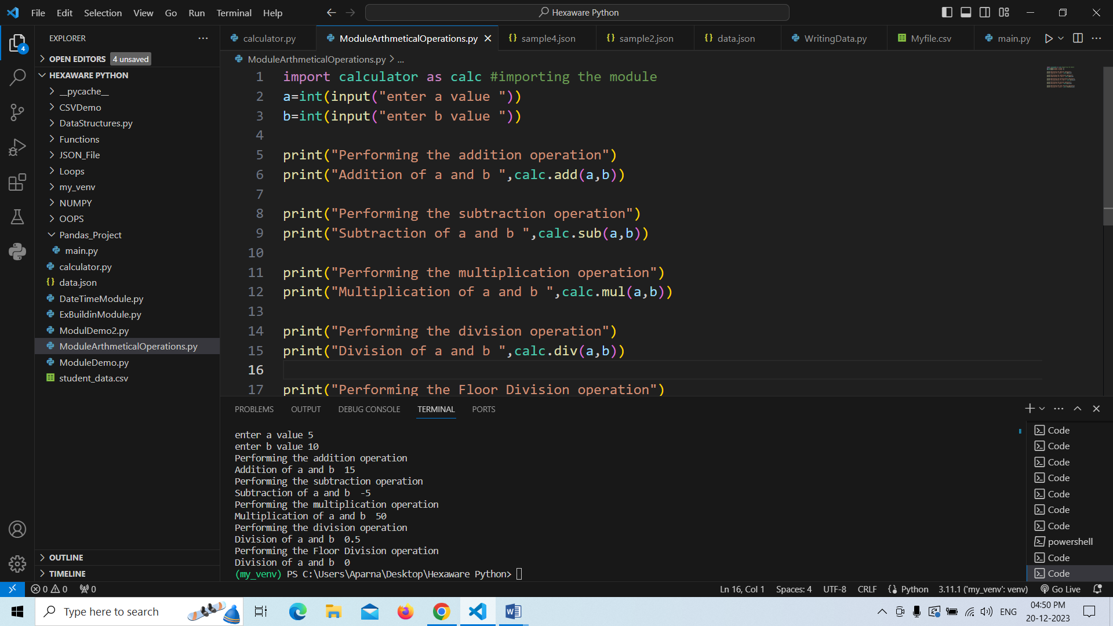

Complete Code

import calculator as calc #Renaming the importing the module

a=int(input("enter a value "))

b=int(input("enter b value "))

print("Performing the addition operation")

print("Addition of a and b ",calc.add(a,b))

print("Performing the subtraction operation")

print("Subtraction of a and b ",calc.sub(a,b))

print("Performing the multiplication operation")

print("Multiplication of a and b ",calc.mul(a,b))

print("Performing the division operation")

print("Division of a and b ",calc.div(a,b))

print("Performing the Floor Division operation")

print("Division of a and b ",calc.floordiv(a,b))

**Output:**

enter a value 5

enter b value 10

Performing the addition operation

Addition of a and b 15

Performing the subtraction operation

Subtraction of a and b -5

Performing the multiplication operation

Multiplication of a and b 50

Performing the division operation

Division of a and b 0.5

Performing the Floor Division operation

Division of a and b 0

**2.Explain Pandas and numpy using Examples in PYTHON**

**Pandas:**Pandas is an open source python library that will use to perform the data analysis like we can easily deal with large type of datasets .

Python Pandas is used in many fileds like in economics,financial management ,statistics etc. By using this we can work on different types of data like it many includes structured ,unstructured data etc.

If we want to use our pandas in our program we need to import as follows

Import pandas as pd

Mainly pandas has two types of data Structures.They are

* DataFrame
* Series

**DataFrame:** It is a two dimentional table with rows and columns .Mostly pandas use these data Structures only.

Import pandas as pd

Info=pd.DataFrame(data)

Here data like lists,tuples ,dictionary etc.

Example:

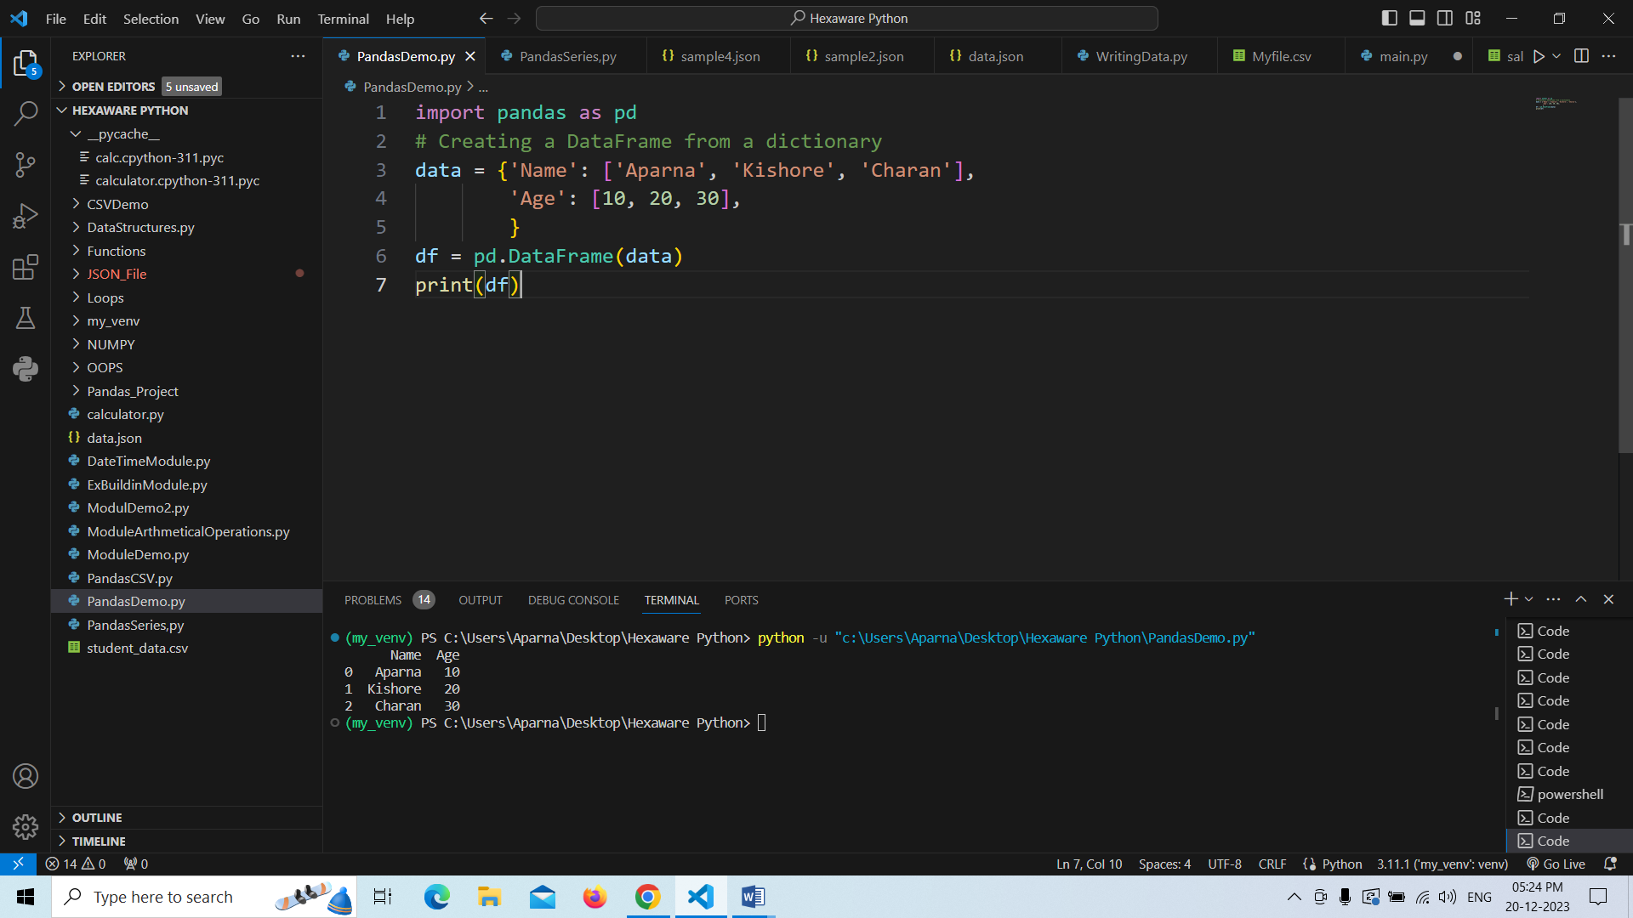

**Series :** This is a data Structure in pandas used to represent the one dimensional array.We can create as follows.

Import pandas as pd

Info=pd.Series(data)

Here data like lists,tuples ,dictionary etc.

Example:

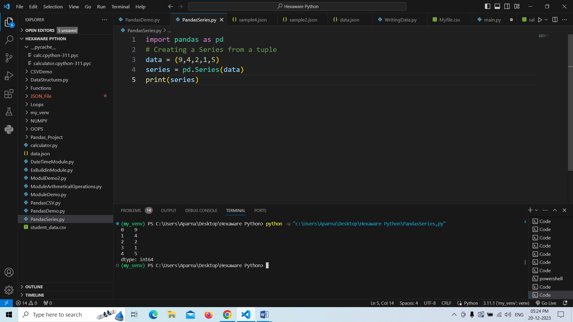

We can also perform file handling operations with pandas.Let see some examples to perform the read and write operations with pandas.

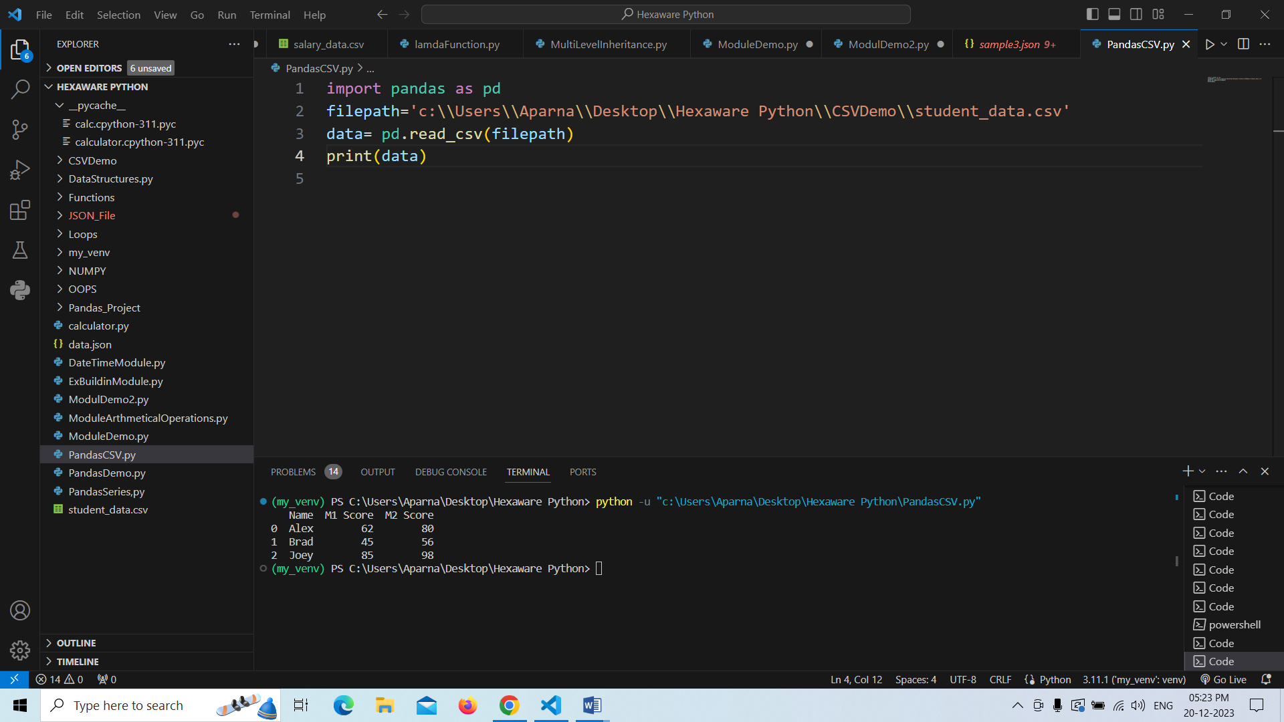

**Numpy in Python:**

* NumPy stands for numeric python which is a python package for the computation and processing of the multidimensional and single dimensional array elements.
* The main data Structure for numpy is Array Object which is helpful to provides analysis of data by performing the calculations in python.

You can import numpy in your program from python library as follows.Let us see some examples

* Example:

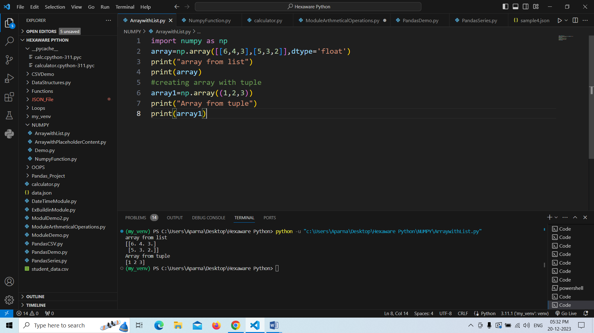

We can do the matrix operations with numpy,Lets see some examples.

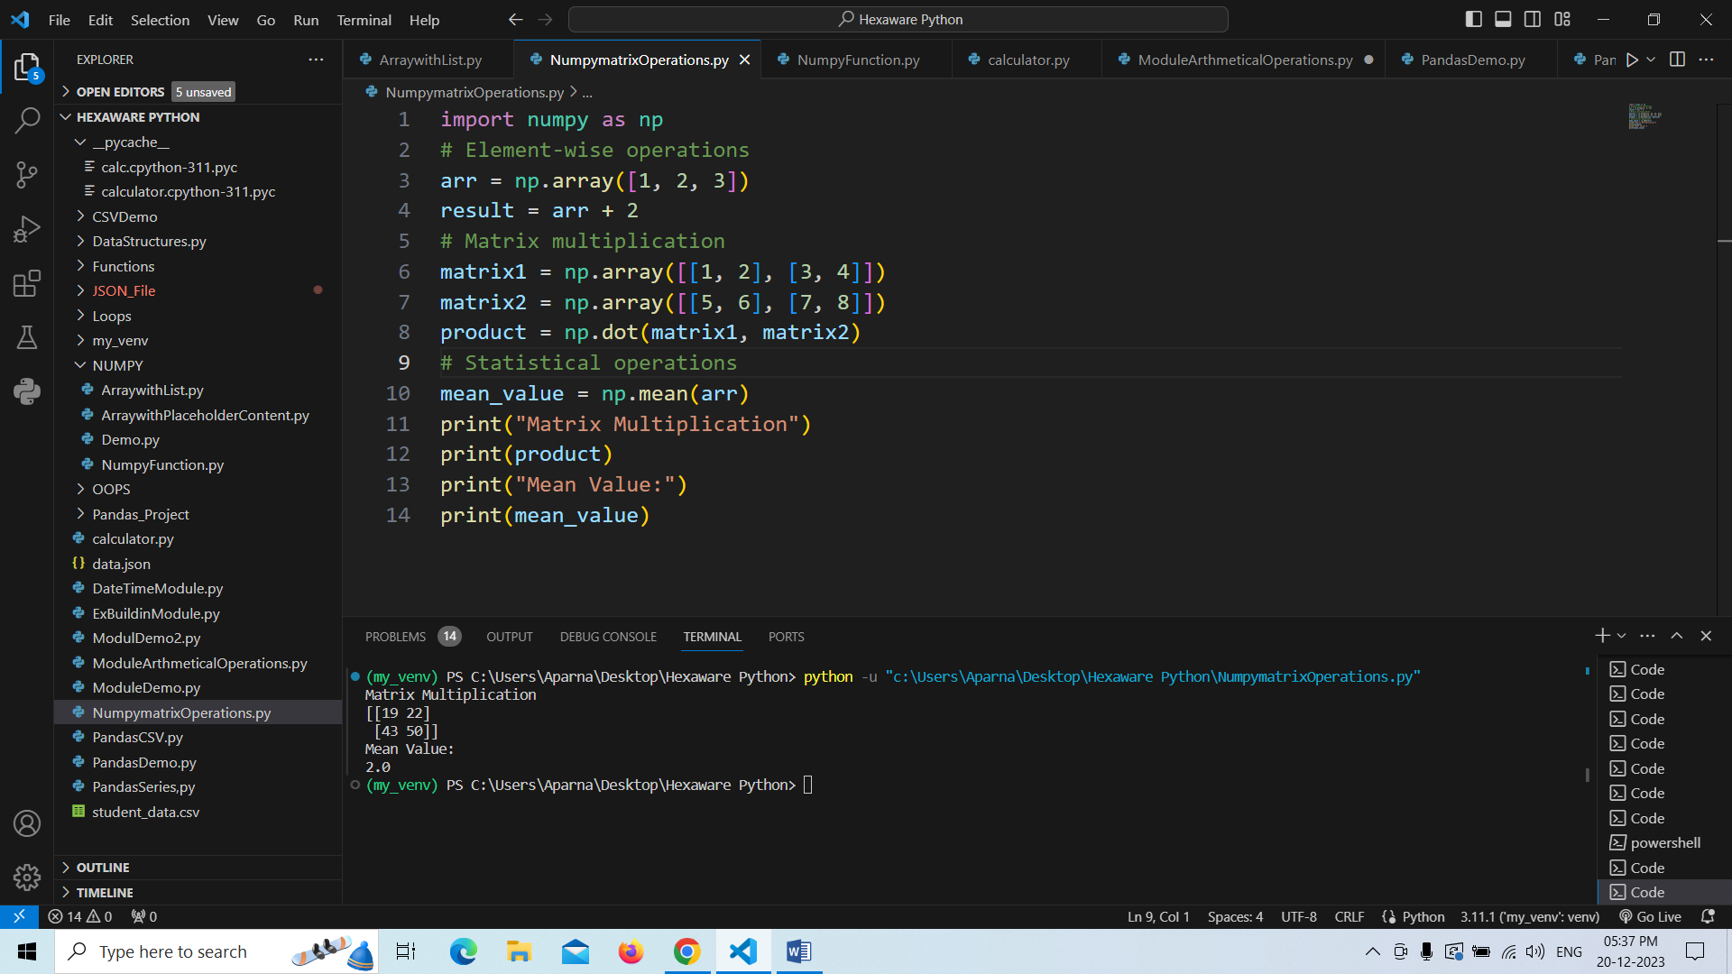

We can have different types of functions that we can perform with the arrays as arange as shown in the below

arange():which is used to return evenly spaces values

reshape()-used to reshape the size of exisiting array.

Flatten()-used to make the given array as one dimentional array. Like these etc.

